**Spartan Market**

**Team 17**

Maan Singh

Tien Ly

Ge Ou

**Project Overview**

“Make your reading not only reading, but also values!”

The database application we are proposing is titled ‘Spartan Market.’ The application is to serve people who enjoy reading and want to benefit from it. Nowadays, people spend a lot of time on social media and watching videos. Although people can relieve stress when they use these applications, but when they are off, people feel lonely and makes them want to go online again which can lead to an addiction. These forms of entertainment do not bring real happiness to people.

According to Felecia in “10 Benefits Of Reading”, she mentions that reading helps people to learn and improves memory, develop good analytical skills, expand their vocabulary, improve writing skills, relaxation, improve concentration, inspire them, even reading with their kids to increase time with families, improve their language skills, and wrap up. We want to create a platform for people who like to read and make that experience worthwhile for them.

The application would have many kinds of books such as Children’s Books, Novels, Magazines, Textbooks, etc. We also plan on selling school supplies, and swag and we want to make this a go-to application for SJSU students. Unlike the school bookstore, we want to allow users to also sell their textbooks and supplies.

* Stakeholders
  + SJSU Students - The targeted user base for our application are the students of the university, so they serve as the primary stakeholders in this project.
  + Team 17 - As developers of this application, we are heavily invested in this project and we want to be able to have this application used by our fellow students.
  + Professor Wu - Professor Mike Wu will be overlooking our project to completion and will be our best resource if we need anything.
* System Environment

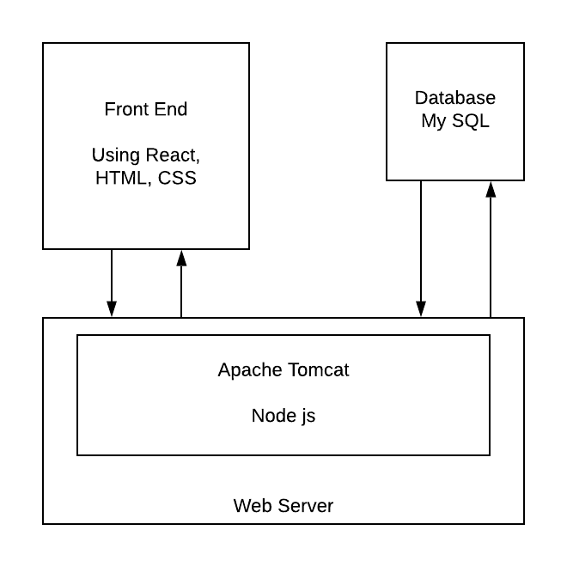

* + Database is MySQL.
  + Languages used is JavaScript.
  + Software for backend is Node.js, Apache HTTP Server
  + Software for frontend is React.js, HTML.
* Functional Requirements

Describe users and how users can access your system

Users can:

* + create a new account
  + login using user ID and password
  + forgot password function
  + save user’s information
  + save user’s payment
  + save user’s cart

Describe each functionality/features, functional processes and I/O(s).

* Items
  + Category
  + Amount
  + Price
  + Producer
* Cart
  + Items which users choose
  + The amount of each item
* Payment page
  + Items
  + Total payment
  + Enter address to ship
  + Confirm payment method
* Map
  + Show our stores in Google Map
* Contact us
  + Website information
  + Email to contact
* Non-functional Issues

Types of Graphical User Interface (GUI) and Software tools to build GUI Security, access control, …

Software to build GUI

* React
* JavaScript
* Html
* Css
* Bootstrap (maybe)
* Git

**Works Cited**

Smith, Felecia. 10 Benefits Of Reading. Technobezz. August 14, 2018. https://www.technobezz.com/10-benefits-of-reading/